Robotics solution for rapid prototyping wins Low Cost Robotics Innovation Competition
Jury awards Robert Hofmann GmbH for time-saving automation concept in 3D printing with robolink D robotic arm

Cost-effective automation of simple tasks is the aim of Low Cost Robotics. Once again this year, the Low Cost Robotics Innovation Competition was looking for exciting ideas and concepts that demonstrate the potential of cost-effective robotic solutions. The winner gets the award at the Motek: The company Robert Hofmann GmbH convinced the jury with its idea for an app-activated pick-and-place application in 3D printing.

Automate simple processes with robots and save time and money. This goal is pursued by not only large industrial players, but also more and more small and medium-sized companies. This is also the case for the company Robert Hofmann GmbH based at Lichtenfels. The company for rapid prototyping faced the following problem. In theory, a 3D printer can print continuously, but after every printing process, the building board must be replaced, what is difficult to handle if a print job ends outside working hours. "Our problem was often that we wanted to print parts that should be ready by the next day if possible," explains Tobias Mager, Training Manager at Robert Hofmann GmbH. "Our trainees, who look after our 3D printers, finish work at 4:15 pm, but the ongoing printing does not finish, for instance, until 5:00 pm. Thus, because of 45 minutes, we would lose over 14 hours of building time, which the printer could theoretically achieve." His solution was the automated replacement of the building board with a robolink D low-cost robotic arm from motion plastics specialist igus, controlled remotely via a smart phone. Thanks to the network connection of the 3D printer, new building processes could be started using the app around the clock on the weekend or after working hours, and the printer could be fully utilised. Tobias Mager submitted his innovative idea to the Low Cost Robotics Innovation Competition.

The awards ceremony at Motek
The concept of Robert Hofmann GmbH convinced the jury composed of members from the fields of research, specialised press and manufacturers. Commitment, refinement and the idea of optimisation led to a unanimous assessment. At the Motek, Maximilian König, representing Robert Hofmann GmbH, was the first to receive a voucher for a robolink D articulated arm or comparable robotic components worth 3,000 euros at the igus trade fair stand. Dr. Sebastian Zug and his RoboCup team robOTTO from the University of Magdeburg could also look forward to the second prize, worth € 1,000. The junior professor developed the idea to use robolink in the RoboCup@work league. In this league, various tasks in industrial environments need to be solved, for example, the transport of screws, nuts, bolts or profiles. Since the previous robotics solution was a discontinued model, Dr. Sebastian Zug designed for his team the concept of using a robolink D robotic arm with 5-axis on an existing Robotino platform. This is feasible because the modular system allows the teams to configure different systems and integrate them into the platform according to the individual gripping and manipulation strategies.

Further information on Low Cost Robotics can be found at https://www.low-cost-robotics.com

Image captions:
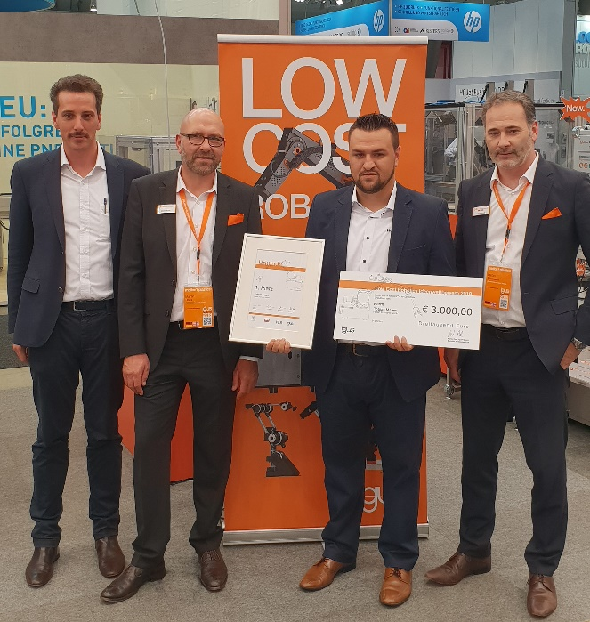
Picture PM6318-1
At Motek Maximilian König of Robert Hofmann GmbH (3rd from the left) received the first prize for the combination of additive manufacturing with Low Cost Robotics. (Source: igus GmbH)

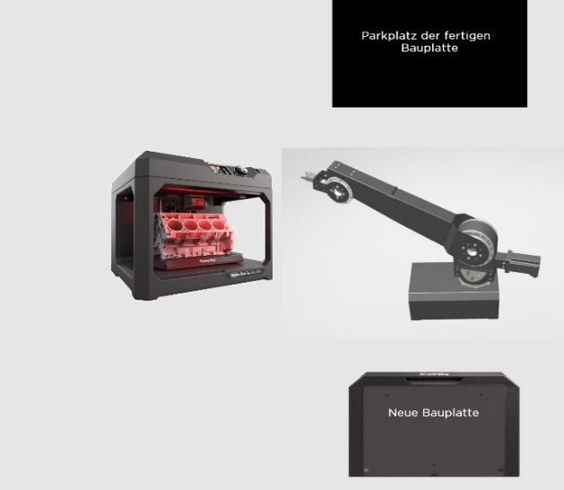
Picture PM6318-2
The winning concept: Simple building board replacement during 3D printing using a robolink D robotic arm. (Source: igus GmbH)

PRESS CONTACT:  Oliver Cyrus  Head of Media and Advertising  igus® GmbH  Spicher Strasse 1a  51147 Cologne  Tel. 0 22 03 / 96 49-459  Fax +49 22 03 / 96 49-631  ocyrus@igus.de  www.igus.de/de/presse | ABOUT IGUS:  igus GmbH is a globally leading manufacturer of energy chain systems and polymer plain bearings. The Cologne-based family business has offices in 35 countries and employs 3.800 people around the world. In 2017, igus generated a turnover of 690 million euros with motion plastics, plastic components for moving applications. igus operates the largest test laboratories and factories in its sector to offer customers quick turnaround times on innovative products and solutions tailored to their needs.

The terms "igus", “Apiro”, "chainflex", "CFRIP", "conprotect", "CTD", "drylin", "dry-tech", "dryspin", "easy chain", "e-chain", "e-chain-systems", "e-ketten", "e-kettensysteme", "e-skin", "flizz", “ibow”, “igear”, "iglide", "iglidur", "igubal", “kineKIT”, "manus", "motion plastics", "pikchain", "plastics for longer life", "readychain", "readycable", “ReBeL”, "speedigus", "triflex", "robolink", and "xiros" are protected by trademark laws in the Federal Republic of Germany and internationally, where applicable.

